A Project Report
ON
JMS HOSPITAL
Submitted in the partial fulfilment of the
Requirement for the award of the degree of
'O' Level from
"Advance School of Information Technology"


Submitted By: Project Guide:
Ritik Gupta (1674672 (1673699)) Er. Chandraprakash( CSE )
Sonali (1716194) Er. Khurshid Alam
Chhaya (1680780) ( ASIT CMD )

Advance School Of Information And Technology
Gauhaniya Panweri Road
Prayagraj 212107 (UP)
Est: 2003
DEC 09 2024

CANDIDATE’S DECLARATION
We declare that this project report presents our work and ideas in our own words and where other ideas or words have been included, we adequately cited and referenced the original sources. We also declare that we have adhered to all principles of academic honesty and integrity and have not misprinted or fabricated or falsified any idea/data/fact/source in our submission. We understand that any violation of the above will be cause for disciplinary action by the Institute and can also evoke penal action from the sources which have thus not been properly cited or from whom paper permission has not been taken when needed.

Ritik Gupta (1673699)
Sonali (1674672)
Chandraprakash (1716194)
Chhaya (1680780)

Advance School Of Information And Technology Gauhaniya Panweri Road Prayagraj 212107 (UP) Est: 2003

Date………………. Signature…………........

List of Figure

Figure No. Figure Name Figure No
Figure. 1 Introduction
Figure. 2 Methodology
Figure. 3 Implementation of Index Page
Figure. 4 Implementation of Sevice Page
Figure. 5 Implementation of Doctors Page
Figure. 6 Implementation of Appointment Page
Figure. 7 Implementation of About Page

Ch.1 Introduction
In the era of digital transformation, e-learning has emerged as a cornerstone for modern education. Our e-learning website is a user-friendly platform designed to provide high-quality educational content to learners of all ages. The website leverages the simplicity and flexibility of HTML, CSS, and W3.CSS to create a clean, and accessible interface. The primary aim of this project is to make online learning accessible and engaging through a visually appealing and well-structured website. By utilizing the lightweight and efficient W3.CSS framework.

- “Home” page that provides an overview of the E-learning and its facility.
- “Service” page provides more extra information about the JMS Hospital, and more about JMS Hospital.
- “Doctors” page provides the information about our courses.
- “Appointment” page provide the information about takin an appointment with your favourable Doctors..
- “About” Page provide the facility to get in touch with us.

Ch.2 Methodology

In this Figurate, we will be discussing about the design procedure of the website which involves the basic flowcharts to describe the various stages of the website.

2.1 Used Technologies

2.1.1 HTML

HTML, or Hyper Text Markup Language, is the standard markup language used to create web pages. It is a fundamental building block of the World Wide Web and is essential for structuring and presenting content on websites. HTML uses a system of tags or elements to define the structure and appearance of a web page. HTML documents consist of text content and HTML tags. Tags are enclosed in angle brackets and come in pairs: an opening tag and a closing tag. The opening tag indicates the beginning of an element, while the closing tag marks the end. Elements can be nested within each other, creating a hierarchical structure that organizes content. Common HTML elements include headings (<h1>,<h2>,etc),
Paragraph(<p>) , Lists(<ul>, <ol>, <,li>), links (<a>), images (<img>), and more.

HTML documents are typically viewed in web browsers, which interpret the HTML code and render it as a visually appealing webpage. Besides content structure, HTML also allows you to add attributes to elements. These attributes provide additional information or settings, like specifying the source of an image, setting the target of a link, or defining styling through CSS (Cascading Style Sheets). In summary, HTML is the essential language for creating web pages. It provides a structure for content and is complemented by other technologies like CSS and JavaScript to make the web visually appealing and interactive. Understanding HTML is crucial for anyone looking to develop websites or work in web-related fields.

2.1.2 CSS

Cascading Style Sheets, commonly known as CSS, is a vital web technology that complements HTML in designing and styling web pages. CSS allows web developers to control the presentation and layout of HTML elements, making web content visually appealing and user-friendly. CSS allows for the separation of content (HTML) and presentation (CSS), enabling web developers to create consistent and easily maintainable designs. It promotes the use of external CSS files, which can be applied to multiple web pages, ensuring a uniform look and feel across a website. With the introduction of CSS3, web developers gained access to advanced features like gradients, animations, and responsive design.
Responsive web design, in particular, is a significant application of CSS that allows websites to adapt to various screen sizes and devices, providing an optimal user experience. In summary, CSS is a powerful technology that controls the appearance and layout of HTML content on the web. It offers a flexible, modular, and efficient way to style web pages, making them visually appealing and adaptable to different devices and screen sizes. CSS is a fundamental skill for web designers and developers looking to create modern and user-friendly websites.

2.1.3 w3-CSS

W3.CSS is a lightweight, responsive, and modern CSS framework developed by W3Schools. It helps developers build web pages quickly with clean and simple designs. Unlike other frameworks, W3.CSS does not require any JavaScript to create interactive and dynamic web pages. Instead, it provides a collection of predesigned CSS classes that can be used to style HTML elements easily.
One of the key features of W3.CSS is its responsiveness. This means that websites designed with W3.CSS will automatically adjust to fit different screen sizes, such as those of mobile phones, tablets, and desktops. It offers built-in styles for grids, navigation bars, buttons, forms, and more, making it easier to create professionallooking layouts without writing much custom CSS code.
W3.CSS also provides a set of colors, fonts, and icons that can be applied to your website. It is minimalistic, which means that it doesn’t bloat your website with unnecessary code, making it fast and efficient. Since it's a free framework, anyone can use it to improve their web design and development process. Overall, W3.CSS is a simple, versatile tool that helps developers create stylish, responsive websites with ease.

2.1.4 Awesome Font

Awesome Font, or Font Awesome, is a popular collection of icons and symbols that can be easily added to websites. It provides a wide range of scalable vector icons, such as social media logos, arrows, and other symbols, which can be customized with CSS for size, color, and effects. Font Awesome is widely used because it is simple to implement and works well with modern web development tools. Instead of using image files for icons, it allows developers to use fonts, making websites faster and more flexible. It's a great resource for enhancing the design of websites or apps

Ch.3 Implementation of Index Page

3.1 Navbar

HTML Code:-
<!--menu section began-->
<nav>
<!--for logo-->
<div class="logo"> JMS HOSPITAL
</div>
<ul>
<li><a href="index.html">HOME </a></li>
<li><a href="courses.html">COURSES</a></li>
<li><a href="notes.html">NOTES</a></li>
<li><a href="about.html"> ABOUT</a></li>
<li><a href="contact.html">CONTACT</a></li>
</ul>
</nav>
<!--menu section end-->

CSS Style .hero {
position: relative;
width: 100%;
height: 450px;
display: flex;
align-items: center;
justify-content: center;
overflow: hidden;
color: #fff;
text-align: center;
}

/* Background Slider Container */
.slider {
position: absolute;
top: 0;
left: 0;
width: 100%;
height: 100%;
z-index: -1;
}
3.2 Main


HTML Code:-
<!-- Hero Section -->
<section class="hero">
<!-- Background Images Slider -->
<div class="slider">
<div class="slide"></div>
<div class="slide"></div>
<div class="slide"></div>
</div>
CSS Style:-
.slide {
position: absolute;
top: 0;
left: 0;
width: 100%;
height: 100%;
background-size: cover;
background-position: center;
opacity: 0;
animation: fadeAnimation 17s infinite;
}

/* Add your background images here */
.slide:nth-child(1) {
background-image: linear-gradient(rgba(0, 120, 150, 0.5), rgba(0, 100, 180, 0.5)), url(H3.png);
animation-delay: 0s;
}

.slide:nth-child(2) {
background-image: linear-gradient(rgba(0, 80, 100, 0.5), rgba(0, 60, 120, 0.5)), url(H1.png);
animation-delay: 5s;
height:700px;
}

.slide:nth-child(3) {
background-image: linear-gradient(rgba(0, 50, 100, 0.5), rgba(0, 50, 100, 0.4)), url(H21.png);
animation-delay: 10s;
background-image:animation-delay;
}
3.3 Course Categories
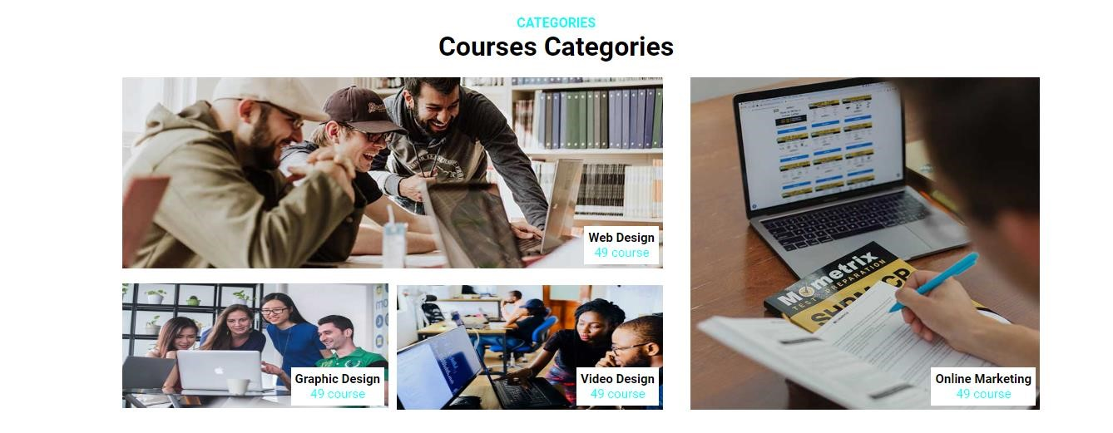
HTML Code:-
<!-- Foreground Content -->
<div class="hero-content">
<h1>आपकी सेहत, हमारी प्राथमिकता</h1>
<p>24/7 बेहतर स्वास्थ्य सेवाएँ और अनुभवी डॉक्टर</p>
<a href="#Appointment" class="btn-book">Book Appointment</a>
<a href="#Emergency Helpline" class="btn-book w3-margin-left w3-background-white w3-red "
>Contact us </a>
</div>
</section>

<table width="98%" class="w3-margin-left "><tr>
<td colspan="9" bgcolor="#111844"> <marquee behavior="alternate" ><font color="white"><big>/***Welcome To Our Hospital***/</big></font></marquee></td>
</tr>

</table>
CSS Style:-
/* Content inside Hero */
.hero-content {
z-index: 1;
}

.hero-content h1 {
font-size: 2.5rem;
margin-bottom: 10px;

}

.hero-content p {
font-size: 1.1rem;
margin-bottom: 20px;
}

.btn-book {
background-color: #00bcd4;
color: white;
padding: 10px 20px;
text-decoration: none;
border-radius: 4px;
font-weight: bold;
display: inline-block;
}

.btn-book:hover {
background-color: #0097a7;
Transition:1s;
}
3.4 Our Services



HTML Code:-
<!--sevice section-->
<div class="w3-container w3-padding-64 w3-white" id="services">

<div class="w3-content">
<h2 class="w3-center w3-text-teal"><b> (Our Services)</b></h2>
<p class="w3-center w3-text-grey">हम आपको बेहतरीन स्वास्थ्य सुविधाएँ प्रदान करते हैं।</p>
<hr class="w3-clear" style="width:50px; margin:auto; border-top:3px solid #009688;">

<div class="w3-row-padding w3-margin-top">
<div class="w3-quarter w3-margin-bottom">

<div class="w3-card w3-padding w3-center service-card w3-round">
<i class="fa-solid fa-heart-pulse w3-text-teal w3-jumbo"></i>
<h4>Cardiology</h4>
<p>हृदय स्वास्थ्य की जाँच और उपचार के लिए विशेषज्ञ।</p>
</div>
</div>
<div class="w3-quarter w3-margin-bottom">
<div class="w3-card w3-padding w3-center service-card w3-round">
<i class="fa-solid fa-brain w3-text-teal w3-jumbo"></i>
<h4>Neurology</h4>
<p>आधुनिक तकनीक से मस्तिष्क और तंत्रिका तंत्र का उपचार।</p>
</div>
</div>
<div class="w3-quarter w3-margin-bottom">
<div class="w3-card w3-padding w3-center service-card w3-round">
<i class="fa-solid fa-bone w3-text-teal w3-jumbo"></i>
<h4>Orthopedics</h4>
<p>हड्डियों और जोड़ों के दर्द का उचित, सरल एवं प्रभावी उपचार।</p>
</div>
</div>
<div class="w3-quarter w3-margin-bottom">
<div class="w3-card w3-padding w3-center service-card w3-round">
<i class="fa-solid fa-baby w3-text-teal w3-jumbo"></i>
<h4>Pediatrics</h4>
<p>बच्चों के स्वास्थ्य की देखभाल एवं टीकाकरण।</p>
</div>
</div>
</div>
</div>
</div>
<table width="98%" class="w3-margin-left ">
<tr>
<td colspan="9" bgcolor="#111844"> <marquee><font color="white"><big>/***Thank You For Visiting Here***/</big></font></marquee></td>
</tr>

CSS Style:-
.container1 { width: 80%; margin: auto; overflow: hidden; padding: 50px; .course-card { width: 300px; border: 1px solid #ddd; border-radius: 5px; padding: 15px; text-align: center; background-color: rgb(240,240,240);

}
.course-card img { width: 100%; height: 200px; object-fit: cover; transition: 1s;
}
.course-card img:hover{ transform: scale(1.1); z-index: 1;
}
.course-card h3 { margin: 10px 0;
} .price { font-size: 20px; color: green;
}
.bt { margin-top: 10px; display: inline-block; padding: 10px 15px; background-color: blue; color: white; text-decoration: none; border-radius: 5px;
}
3.5 Footer:
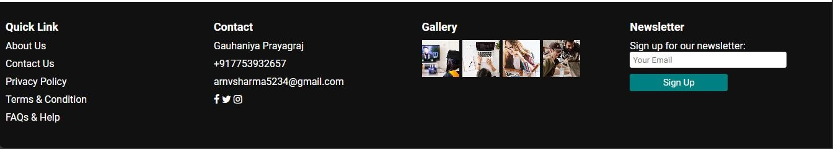
W3-Css Code:-
<footer class="footer">
<div class="ab">
<!-- Quick Links Section --> <div class="footer-section">
<h3>Quick Link</h3>
<ul>
<li><a href="about.html">About Us</a></li>
<li><a href="contact.html">Contact Us</a></li>
<li><a href="#">Privacy Policy</a></li>
<li><a href="#">Terms & Condition</a></li>
<li><a href="#">FAQs & Help</a></li>
</ul>
</div>

<!-- Contact Section -->
<div class="footer-section">
<h3>Contact</h3>
<ul>
<li>Gauhaniya Prayagraj</li>
<li>+917753932657 </li>
<li>arnvsharma5234@gmail.com</li>
<li>
<a href="https://www.facebook.com/" class="w3-margin-right" target="blank"><i class="fa fa-facebook"></i></a>
<a href="https://x.com/?lang=en-in" class="w3-margin-right" target="blank"><i class="fa fa-twitter"></i></a>
<a href="https://www.instagram.com/" class="w3-margin-right" target="blank"><i class="fa fa-instagram"></i></a>
</li>
</ul>
</div>

<!-- Gallery Section -->
<div class="footer-section">
<h3>Gallery</h3>
<div class="gallery">
<img src="img/course-1.jpg" alt="Gallery Image">
<img src="img/course-2.jpg" alt="Gallery Image">
<img src="img/course-3.jpg" alt="Gallery Image">
<img src="img/cat-1.jpg" alt="Gallery Image">
</div>
</div>

<!-- Newsletter Section -->
<div class="footer-section">
<h3>Newsletter</h3>
<p>Sign up for our newsletter:</p>
<form>
<input type="email" placeholder="Your Email">

<button type="submit" style="font-size: 15px;">Sign Up</button>
</form>
</div>
</div>
</footer>
CSS Style:
.footer { background-color: #111; color: #fff; padding: 20px 0; font-family: Arial, sans-serif;
}

.ab { display: flex; justify-content: space-around; flex-wrap: wrap;
}

.footer-section { flex: 1 1 200px; margin: 10px;
}

.footer-section h3 { font-size: 18px; margin-bottom: 10px;
}

.footer-section ul { list-style: none; padding: 0;
}

.footer-section ul li { margin-bottom: 10px;
}

.footer-section ul li a { color: #fff; text-decoration: none; cursor: pointer;
}

.footer-section ul li a:hover { text-decoration: underline;
}

.gallery { display: flex; flex-wrap: wrap; gap: 5px; }

.gallery img { width: 60px; height: 60px; object-fit: cover; }

.footer-section form { display: flex; flex-direction: column;
}

.footer-section input[type="email"] { padding: 5px; margin-bottom: 10px; width: 80%; border: none; border-radius: 3px;
}

.footer-section button { padding: 5px 10px; background-color: teal; color: #fff; border: none; cursor: pointer; height: 50%; width: 50%; float: right; border-radius: 3px;
}

.footer-section button:hover { background-color: #005f5f;
}

Ch-4 Technology to build About Page
4.1 Body Section

Html Code:
<div class="about">
<div class="aboutimg" >
<img src="img/about.jpg" alt="" height="450px" width="500px" style="object-fit: cover;">
</div>
<div class="aboutcontent">
<h6>ABOUT US</h6>
<h1 class="">Welcome to eLEARNING</h1>
<p>Our mission is to bridge the gap between learners and highquality education by offering a platform that is not only user-friendly but also rich in resources. We envision a future where education transcends boundaries and reaches every corner of the globe. Our goal is to empower individuals by equipping them with the skills and knowledge necessary to thrive in an everchanging world..</p>
<div class="aboutdiv1">
<div class="aboutdiv-1">
<p class="aboutdiv-1p1">
<i class="fa fa-arrow-right text-primary me-2">

</i>Skilled Instructors</p>
</div>
<div class="aboutdiv-1">
<p class="aboutdiv-1p2">
<i class="fa fa-arrow-right text-primary me-2">

</i>Online Classes</p>
</div>
<div class="aboutdiv-1">
<p class="aboutdiv-1p3">
<i class="fa fa-arrow-right text-primary me-2">

</i>International Certificate</p>
</div>
</div>

<div class="aboutdiv2">
<div class="aboutdiv-1">
<p class="aboutdiv-1p4"><i class="fa fa-arrow-right text-primary me-2"></i>Skilled Instructors</p>
</div>
<div class="aboutdiv-1">
<p class="aboutdiv-1p5"><i class="fa fa-arrow-right text-primary me-2"></i> International Certificate</p></p>
</div>
<div class="aboutdiv-1">
<p class="aboutdiv-1p6"><i class="fa fa-arrow-right text-primary me-2"></i>Online Classes</p>
</div>
<div>
<a href="#" class="button">Read More</a>
</div>
</div>
</div>
</div>
CSS Style:-
.about{

width: 100%;

margin-top: 40px; display: flex; justify-content:center;

}
.aboutimg{ float: left; width: 45%; position: relative; left: 55px; z-index: 0;

}
.aboutcontent {

width: 40%; float: left;

}

.aboutcontent h6{ font-size: 18px; font-weight: 500; color: #18d4e6; font-family:Arial, Helvetica, sans-serif; margin: 0 0 4px 0px; padding: 0 0 8px;
}

.aboutcontent h1{ font-size:40px; margin: 0 0 30px 0px;

}

.aboutcontent .aboutpara1{ margin: 0 0 25px 0px; font-size:16px; color: rgb(59, 56, 56);
}

.aboutcontent .aboutpara2{ margin: 0 0 20px 0px; color:rgb(59,56,56) ;
}

.aboutdiv1{ float: left;

}
.aboutpara2{ padding: 12px 0;
}

.aboutdiv-1 { margin: 0 30px 20px 0px;

}

.aboutdiv-1 i{ font-size: 18px; color:#2dd3e2;

}
.aboutdiv2.button{ margin: 10px 40px;

}
.button{ background-color:#06BBCC; margin: 0px 30px 20px 0; color: #fff; padding: 20px 60px; border: none; position: absolute; font-size: 18px;
}
.button:hover{ background-color:#13ebff; color: white;
}
4.1.2

HTML Code:-
<section class="service-box">
<div class="service">
<div class="boxitems" >
<i class=" fa fa-3x fa-graduation-cap text-primary mb-4" ></i>
<h6>Skilled Instructors</h6>
<p>Provide Exprienced & Expext Instuctor</p>
</div>
<div class="boxitems">
<i class="fa fa-3x fa-globe text-primary mb-4"></i>
<h6>Online Classes</h6>
<p>Provide Live & Recorded Classes</p></div>
<div class="boxitems">
<i class=" fa fa-3x fa-home text-primary mb-4"></i>
<h6>Home Projects</h6>
<p>Provide Real Life & Live Projects</p></div>
<div class="boxitems">
<i class="fa fa-3x fa-book text-primary mb-4"></i>
<h6>Book Library</h6>
<p> Provide E-Notes</p></div>

</div>
</section>
CSS Style:-
.service-box{
text-align: center; padding: 25px 0px;
}
.service{ display: flex;
/*background-color: black;*/ padding: 100px; margin: auto; width: 100%; height: 380px; flex-wrap: wrap; justify-content: space-around;
}
.boxitems{
background: #cefbff; margin: 10px 0px; flex-basis: 23%; height: 230px; width: 20%; text-align: center; overflow:hidden;

}
.boxitems i{ color: #13ebff; font-size: 60px; padding: 20px 0;
}
.boxitems h6{ font-size: 20px; padding: 10px 0;
}
.boxitems p{ font-size: 16px; font-weight: 100; text-align:center; padding: 10px;
}
.boxitems:hover{ background-color:#2ccad8; opacity: .89; transform: scale(0.9); z-index: 2;
transition: 1s;
}
.boxitems:hover i ,.boxitems:hover h6,.boxitems:hover p{ color: white; transform: translate(-0%, -7%);

}
4.1.3

HTML Code:-
<section class="instructors">
<h4 style="text-align: center; color: cyan;s">INSTRUCTORS</h4>
<h1>Expert Instructors</h1>
<div class="instructor-container">
<div class="instructor">
<img src="img/cmd.jpeg" alt="Instructor Image">
<h3>Er. Khurshid Alam</h3>
<p>C.M.D.</p>
</div>
<div class="instructor">
<img src="img/anil.jpeg" alt="Instructor Image">
<h3>Er. Anil Sonkar</h3>
<p>IT Chief</p>
</div>
<div class="instructor">
<img src="img/div.jpeg" alt="Instructor Image">
<h3>Er. Divyanshu Yadav</h3>
<p>CSE</p>
</div>
<div class="instructor">
<img src="img/sam.jpeg" alt="Instructor Image">
<h3>Er. Sandeep Gautam</h3>
<p>LT</p>
</div>
</div>
</section>
CSS Style:-
.instructors { text-align: center; padding: 20px;
}

.instructors h1{ font-size: 24px; margin-bottom: 20px;
}

.instructor-container { display: flex; justify-content: center; gap: 30px;
flex-wrap: wrap;
}

.instructor { background-color: rgb(240,240,240); padding: 15px; text-align: center; width: 200px;
}

.instructor img { width: 100%; margin-bottom: 10px; transition: 1s;/*for smoth the images*/

}
.instructor img:hover{ transform: scale(1.1);/*div ke size badane ke lea*/ z-index: 1;
}

.instructor h3 { font-size: 18px; margin: 5px 0;
}

.instructor p { color: #555; font-size: 14px;}
4.1.4
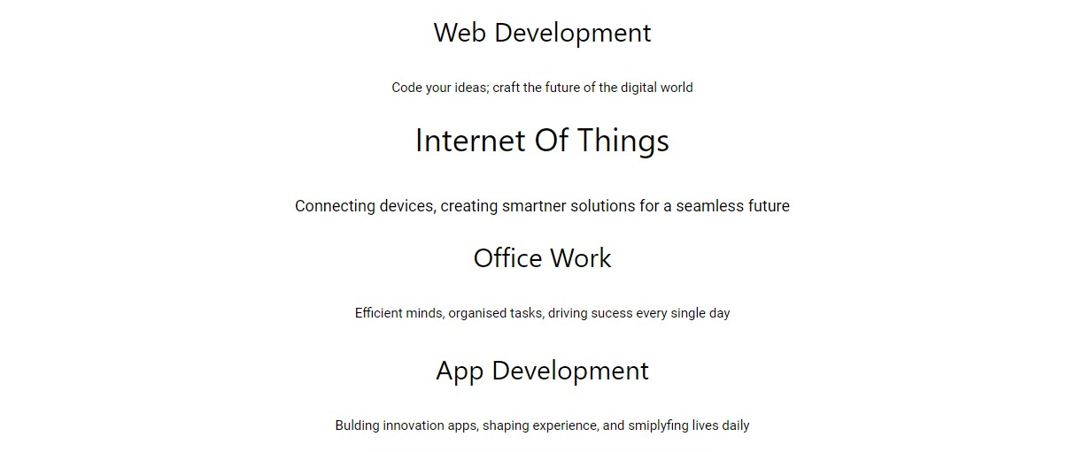
HTML Code:-
<div class="main">
<div class="cards">
<div class="title">
<h2 style="margin: 10px;padding: 5px; ">Web Development</h2> </div>
<div class="des">
<p style="text-align: center; margin: 20px; padding: 5px;">Code your ideas; craft the future of the digital world</p>
</div>
</div>
<!--copy the code two times jo uper hai-->
<!--second card -->
<div class="cards">
<div class="title">
<h2 style="margin: 10px;padding: 5px; ">Internet Of Things</h2> </div>
<div class="des">
<p style="text-align: center; margin: 20px; padding: 5px;">Connecting devices, creating smartner solutions for a seamless future</p>
</div>
</div>
<!--third card -->
<div class="cards">
<div class="title">
<h2 style="margin: 10px;padding: 5px; ">Office Work</h2>
</div>
<div class="des">
<p style="text-align: center; margin: 20px; padding: 5px;">Efficient minds, organised tasks, driving sucess every single day</p>
</div>
</div>
<!--fourth card -->
<div class="cards">
<div class="title">
<h2 style="margin: 10px;padding: 5px; ">App Development</h2>
</div>
<div class="des">
<p style="text-align: center; margin: 20px; padding: 5px;">Bulding innovation apps, shaping experience, and smiplyfing lives daily</p>
</div>
</div>
</div>
CSS Style:-
.title{ text-align: center;}
.cards:hover{
transform: scale(1.2);
transition: 1s;
}

Ch-6 Technology to build Login Page
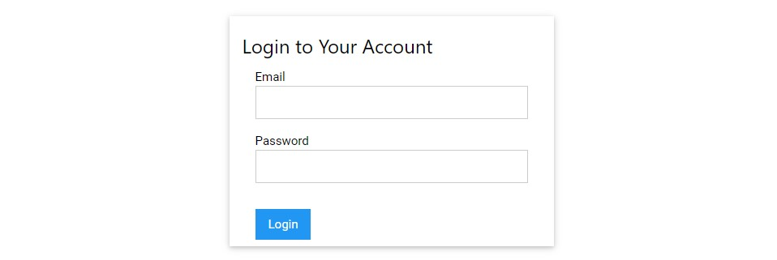

Html Code:
<div class="form-container w3-card w3-white w3-padding">
<!-- Login Form -->
<div id="loginForm" style="display: block;">
<h3>Login to Your Account</h3>
<form class="w3-container">
<label>Email</label>
<input class="w3-input w3-border w3-margin-bottom" type="email" required>

<label>Password</label>
<input class="w3-input w3-border w3-margin-bottom" type="password" required>

<button class="w3-button w3-blue w3-margin-top" type="submit">Login</button>
</form>
</div>
CSS Style:
.form-container { max-width: 400px; margin: 20px auto; padding: 16px;
background: rgba(255, 255, 255, 0.85);
}

Ch-7 Technology to build Notes Page
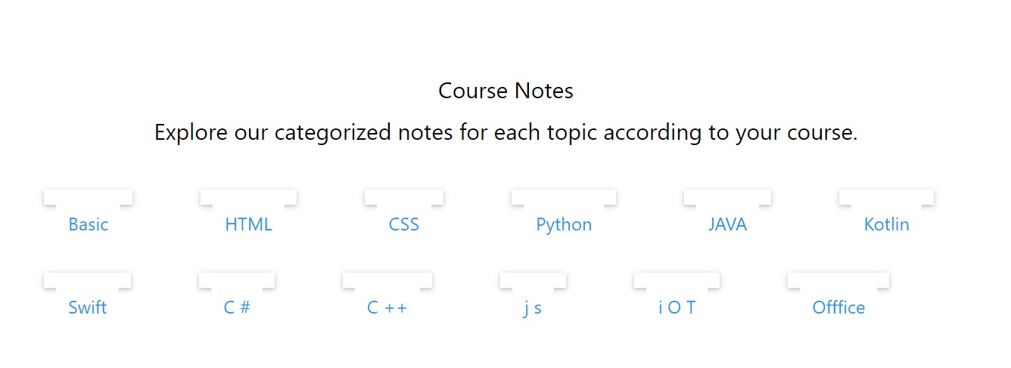

HTML Code:

<div class="w3-container w3-padding-64">
<h2 class="w3-center">Course Notes</h2>
<h2 class="w3-center">Explore our categorized notes for each topic according to your course.</h2>

<!-- Basic Category -->
<a href="PDF/Basic.pdf" target="blank">
<div class="note-category blk w3-card w3-white w3-padding"> <h3 class="w3-text-blue w3-block w3-button w3-centeralign">Basic</h3>
</div></a>
<!-- HTML Category -->
<a href="PDF/HTML.pdf" target="blank">
<div class="note-category blk w3-card w3-white w3-padding">
<h3 class="w3-text-blue w3-button w3-block w3-left-align"> HTML</h3>
</div></a>
<!-- CSS Category -->
<a href="PDF/CSS.pdf" target="blank">
<div class="note-category blk w3-card w3-white w3-padding">
<h3 class="w3-text-blue w3-button w3-block w3-left-align"> CSS</h3>
</div></a>
<!-- Pyhton Category -->
<a href="PDF/Python.pdf" target="blank">
<div class="note-category w3-card blk w3-white w3-padding">
<h3 class="w3-text-blue w3-button w3-block w3-left-align"> Python</h3> </div></a>

<!-- JAVA Category -->
<a href="PDF/JAVA.pdf" target="blank">
<div class="note-category w3-card blk w3-white w3-padding">
<h3 class="w3-text-blue w3-button w3-block w3-left-align"> JAVA</h3>
</div></a>
<!-- kotlin Category -->
<a href="PDF/Kotlin.pdf" target="blank">
<div class="note-category w3-card blk w3-white w3-padding">
<h3 class="w3-text-blue w3-button w3-block w3-left-align"> Kotlin</h3>
</div></a>
<!-- Swift Category -->
<a href="PDF/Swift.pdf" target="blank">
<div class="note-category w3-card blk w3-white w3-padding">
<h3 class="w3-text-blue w3-button w3-block w3-left-align"> Swift</h3>
</div></a>
<!-- C# Category -->
<a href="PDF/Csharp.pdf" target="blank">
<div class="note-category w3-card blk w3-white w3-padding">
<h3 class="w3-text-blue w3-button w3-block w3-left-align"> C #</h3>
</div></a>
<!-- C++ Category -->
<a href="PDF/C++.pdf" target="blank">
<div class="note-category w3-card blk w3-white w3-padding">
<h3 class="w3-text-blue w3-button w3-block w3-left-align"> C ++</h3>
</div></a>
<!-- JS Category -->
<a href="PDF/js.pdf" target="blank">
<div class="note-category blk w3-card w3-white w3-padding">
<h3 class="w3-text-blue w3-button w3-block w3-left-align"> j s</h3>
</div></a>
<!-- iOT Category -->
<a href="PDF/iOT.pdf" target="blank">
<div class="note-category blk w3-card w3-white w3-padding">
<h3 class="w3-text-blue w3-button w3-block w3-left-align"> i O T</h3>
</div></a>
<!-- Office Category -->
<a href="PDF/Office.pdf" target="blank">
<div class="note-category blk w3-card w3-white w3-padding">
<h3 class="w3-text-blue w3-block w3-button w3-centeralign">Offfice</h3>
</div></a>

</div>
CSS Style:
.note-category { margin: 20px 0;
} .blk{ display: inline; float: left; margin: 45px; transition: background-color 0.3s; height: 20px;
}

Ch-8 Technology to build Contact Page
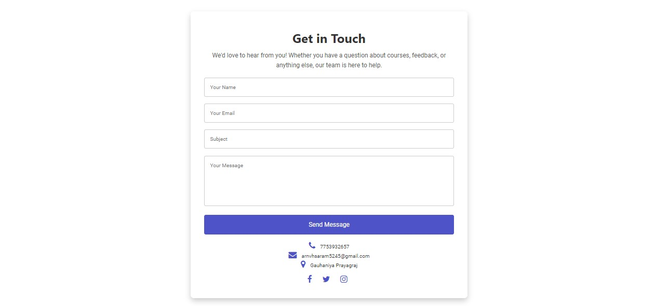

HTML Code:
<div class="contact-section">
<div class="contact-container w3-animate-opacity">
<h2 class="contact-title w3-center">Get in Touch</h2>
<p class="contact-description w3-center">
We'd love to hear from you! Whether you have a question about courses, feedback, or anything else, our team is here to help.
</p>

<!-- Contact Form -->
<form class="contact-form">
<input type="text" placeholder="Your Name" required>
<input type="email" placeholder="Your Email" required>
<input type="text" placeholder="Subject" required>
<textarea rows="5" placeholder="Your Message" required></textarea>
<button type="submit">Send Message</button>
</form>

<!-- Contact Info with Icons -->
<div class="contact-info w3-center">
<p><i class="fa fa-phone"></i> 7753932657</p>
<p><i class="fa fa-envelope"></i> arnvhsaram5245@gmail.com</p>
<p><i class="fa fa-map-marker"></i> Gauhaniya Prayagraj</p>

<!-- Social Media Links -->
<div class="w3-margin-top">
<a href="#" class="w3-margin-right"><i class="fa fafacebook"></i></a>
<a href="#" class="w3-margin-right"><i class="fa fatwitter"></i></a>
<a href="#" class=""><i class="fa fa-instagram"></i></a>
</div>
</div>
</div>
</div>
CSS Code:
.contact-section {

background-size: cover; color: white; padding: 50px 0;
}
.contact-container { max-width: 800px; margin: auto; background: rgba(255, 255, 255, 0.85); padding: 40px; border-radius: 10px; box-shadow: 0 8px 16px rgba(0, 0, 0, 0.2);
}
.contact-title { font-size: 36px; font-weight: bold; color: #333;
}
.contact-description { font-size: 18px; color: #555; margin-bottom: 20px; line-height: 1.6;
}
.contact-form input, .contact-form textarea { margin-bottom: 20px; padding: 15px; width: 100%; border-radius: 5px; border: 1px solid #ccc;
}
.contact-form textarea { resize: none;
}
.contact-form button { width: 100%; padding: 15px; background-color: #4e54c8; color: white; border: none; border-radius: 5px; font-size: 18px; cursor: pointer; transition: background-color 0.3s ease;
}
.contact-form button:hover { background-color: #8f94fb;
}
/* Icons and social media links */
.contact-info { margin-top: 20px; color: #333;
}
.contact-info i { font-size: 24px; margin-right: 10px; color: #4e54c8;
}
/* Responsive */
@media (max-width: 600px) {
.contact-title { font-size: 28px;
}
}

